FBCJ– Cash Expenses
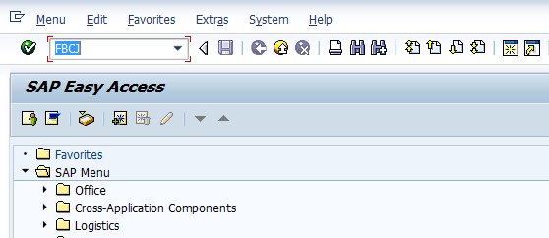
- Input FBCJ in Transaction box and press Enter key

Cash Journal
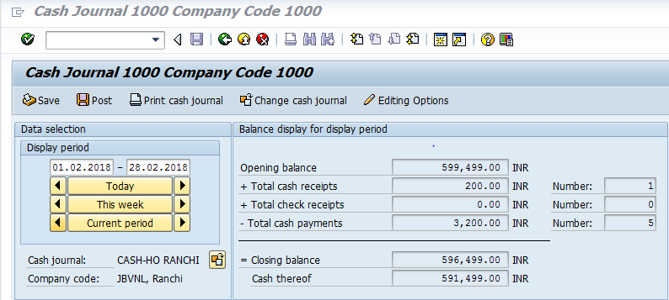
The following are the important sections (tabs) under the Cash Journal screen
- Cash Payments: Under this section the transactions related to Payments such as expenses payments, Vendor payments will be carried out in this section
- Cash Receipts: Under this section the transactions related to Receipts such as Advances, Incoming Receipts will be recorded in this section
- Check Receipts: Under this section the transaction related to Receipts from Bank such as Customer Advance, Vendor security deposit will be recorded in this section

Cash Payments:
The following are the input fields under the Cash Payments tab
- Business Transaction: Place the cursor on the field and press F4. System will display one window with list of options, where we need to select the respective Business Transaction and press Enter key
- Amount : Input the amount
- G/L Account: Place the cursor on the field and press F4. List of GL Accounts will appear, select respective GL Account and press Enter key
- Text: Input the text information in this field
- Vendor: Input the respective Vendor account number( for the vendor whom we are making payment)
- Customer: Input the respective Customer number(from the customer where we are receiving amounts)
- Posting Date: System will automatically take the current date as Posting date
- Document Number: Once document got successfully posted the document number will appear in this field
- Reference: Input the reference information in this field
- Cost Center: Input the respective cost center information in this field
- Profit Center: Input the respective Profit center information in this field

3.1 Expenses (Cash Outflow) in Cash Payments
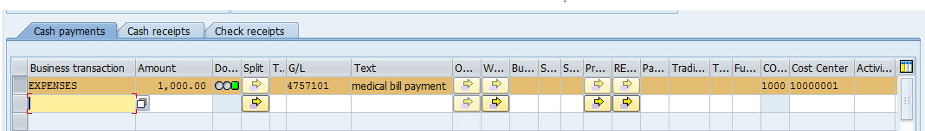
- Place the cursor on Business Transaction field and press F4.
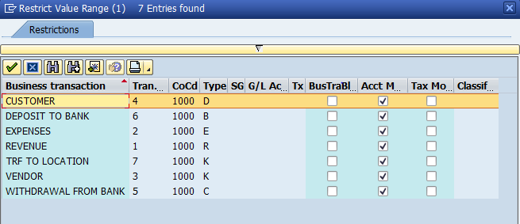
- Select “Expenses (Cash Outflow)” transaction and press Enter key
- Input the Amount
- Update the Medical Expenses GL Account in the GL Account field
- Update the relevant text information
- Update the relevant Cost center in Cost center field
- Profit center will automatically get updated as per configured
- Press Enter key and click on Post option
- Document will post successfully and line item status will turn in to Green colour. Document number will get updated in the Document field Eg: 297 in the above screen shot

3.2 Cash Transfer withing Location:
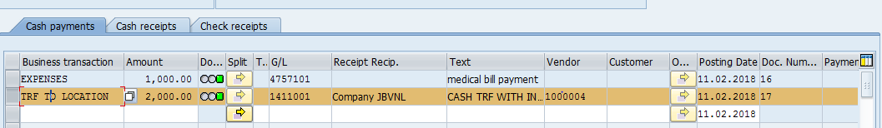
- Place the cursor on Business Transaction field and press F4. Select “Cash Transfer within Location” transaction and press Enter key
- Input the Amount
- Update the Vendor Account(Employee Vendor Account number) in Vendor Field
- Update the relevant text information
- Update the relevant Profit center information
- Press Enter key and click on Post option
- Document will post successfully and line item status will turn in to Green colour. Document number will get updated in the Document field Eg: 298 in the above screen shot

3.3 Cash Deposit in to Bank
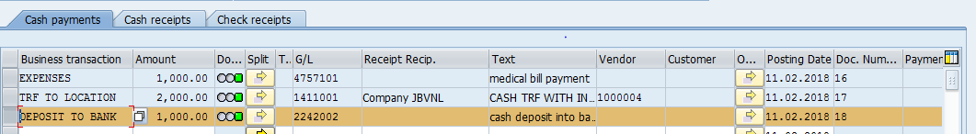
- Place the cursor on Business Transaction field and press F4. Select “ Deposit to Bank” transaction and press Enter key
- Input the Amount
- Update the Bank Outgoing GL Account in GL Account Field
- Update the relevant text information
- System will automatically pick up the profit center as default settings configured
- Press Enter key and click on Post option
- Document will post successfully and line item status will turn in to Green colour. Document number will get updated in the Document field Eg: 308 in the above screen shot

4. Cash Receipts:
The following are the input fields under the Cash Receipts tab
- Business Transaction: Place the cursor on the field and press F4. System will display one window with list of options, where we need to select the respective Business Transaction and press Enter key
- Amount : Input the amount
- G/L Account: Place the cursor on the field and press F4. List of GL Accounts will appear, select respective GL Account and press Enter key
- Text: Input the text information in this field
- Vendor: Input the respective Vendor account number( for the vendor whom we are making payment)
- Customer: Input the respective Customer number(from the customer where we are receiving amounts)
- Posting Date: System will automatically take the current date as Posting date
- Document Number: Once document got successfully posted the document number will appear in this field
- Reference: Input the reference information in this field
- Cost Center: Input the respective cost center information in this field
- Profit Center: Input the respective Profit center information in this field

4.1 Cash Withdrawal from Bank
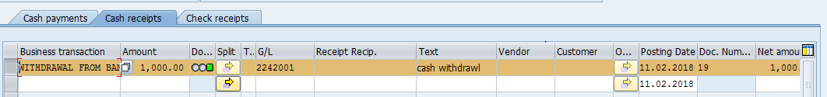
- Place the cursor on Business Transaction field and press F4. Select “With drawl from bank” transaction and press Enter key
- Input the Amount
- Update the Bank Incoming GL Account in GL Account field
- Update the relevant text information
- Input the Profit center information in Profit center field
- Press Enter key and click on Post option
- Document will post successfully and line item status will turn in to Green colour. Document number will get updated in the Document field Eg: 306 in the above screen shot

4.2 Revenue (Cash Inflow)
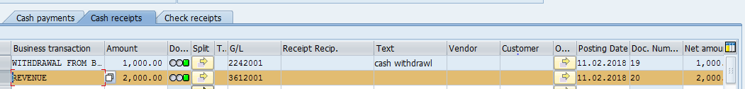
- Place the cursor on Business Transaction field and press F4. Select “Revenue” transaction and press Enter key
- Input the Amount
- Update the respective GL Account in GL Account field
- Update the relevant text information
- Input the Profit center information in Profit center field
- Press Enter key and click on Post option
- Document will post successfully and line item status will turn in to Green colour.

Manual End

